

***School of Mechanical & Manufacturing Engineering (SMME),***

***National University of Science and Technology (NUST),***

***Sector H-12, Islamabad***

Program: BE-Aerospace Section: AE-01

Session: Fall 2023 Semester: 1st

Course Title: Fundamentals of Programming (CS-109)

**Assignment:**

***Name: Anzish Fatima***

***CMS:*** 464627

1. Write a C++ program, take two strings as input from user and check if both strings are equal or not. If they are equal make them unequal by rotating string. e.g., Hello is turned into olleH etc.

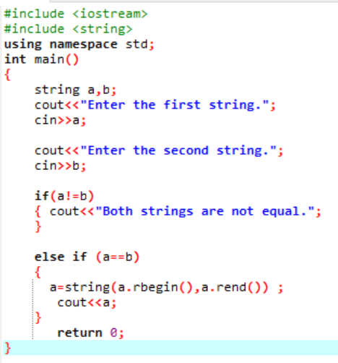

**Case 1:**

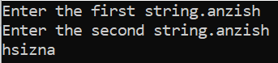

**Case 2:**

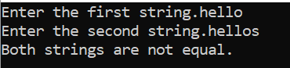

2. Write a C++program for a string which may contain lowercase and uppercase characters. The task is to remove all duplicate characters from the string and find the resultant string.

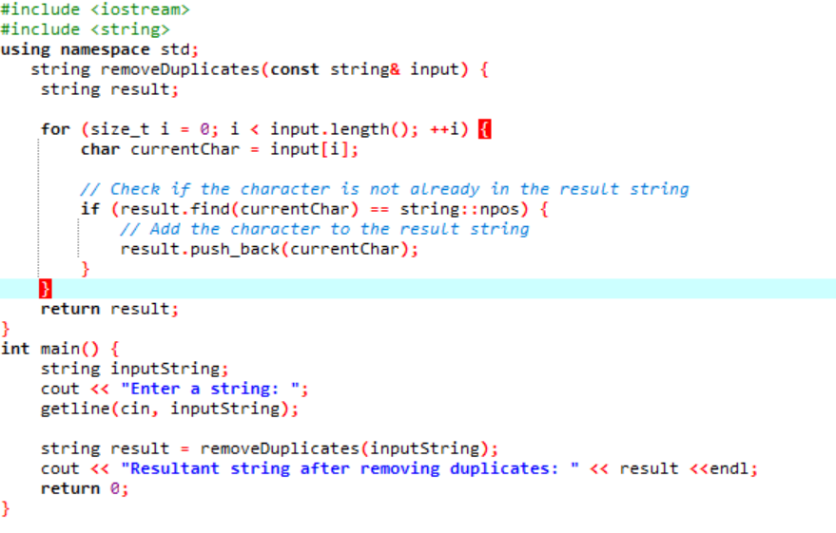

**Output:**

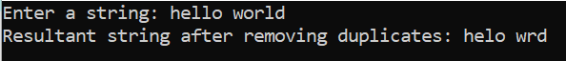

3. Suppose an integer array a [5] = {1, 2, 3, 4, 5}. Add more elements to it and display them in C++.

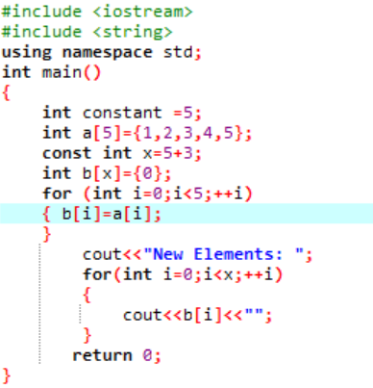

**Output:**



4. Write a C++ program that uses a while loop to find the largest prime number less than a given positive integer N. Your program should take the value of N as input from the user and then find the largest prime number less than or equal to N. You are not allowed to use any library or pre-existing functions to check for prime number.

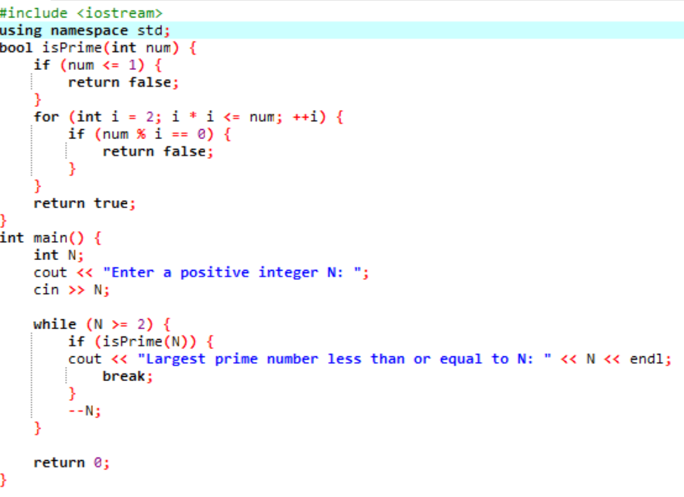

**Output:**

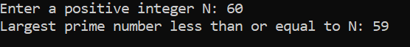

5. Implement Bubble Sort on an array of 6 integers.

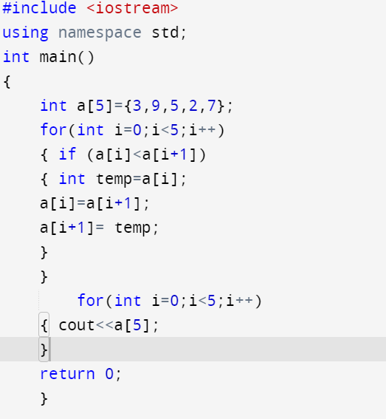

**Output:**



6. Solve any Aerospace/Real Life Problem using C++ Programming.

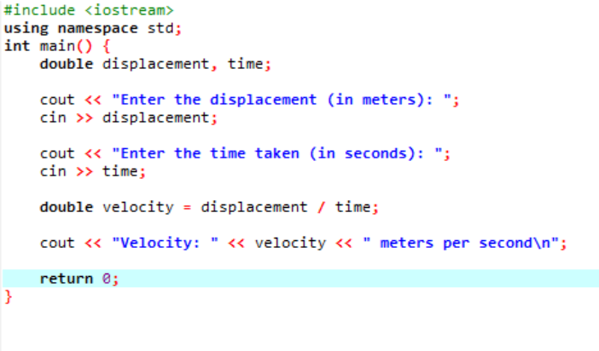

**Output:**

